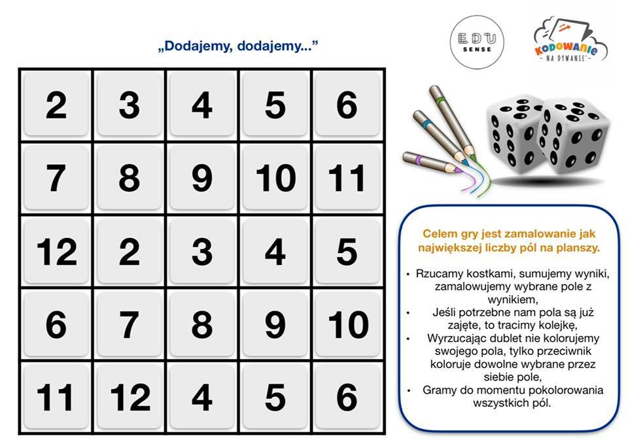

Źródło: https://www.facebook.com/photo.php?fbid=1599131350242582&set=pcb.820999901731142&type=3&theater&ifg=1
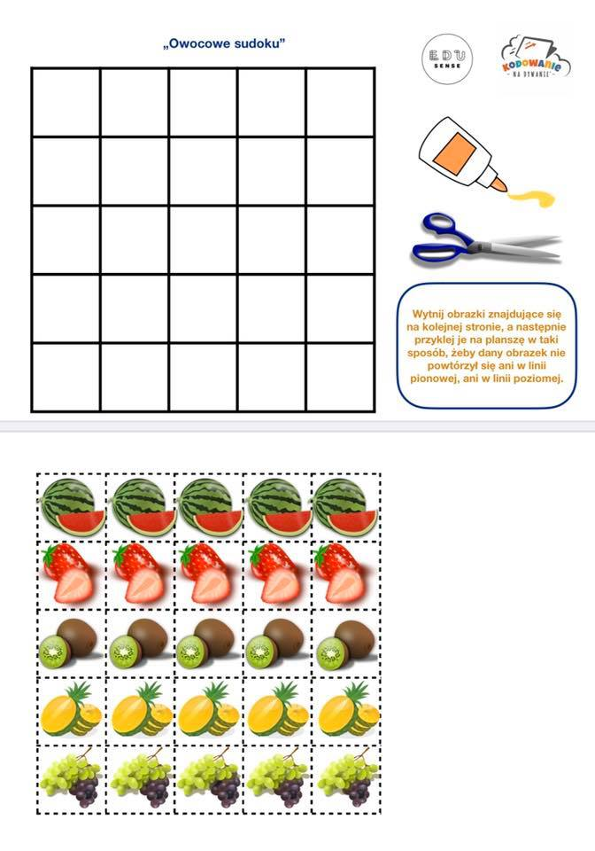Źródło: https://www.facebook.com/photo.php?fbid=1599131350242582&set=pcb.820999901731142&type=3&theater&ifg=1
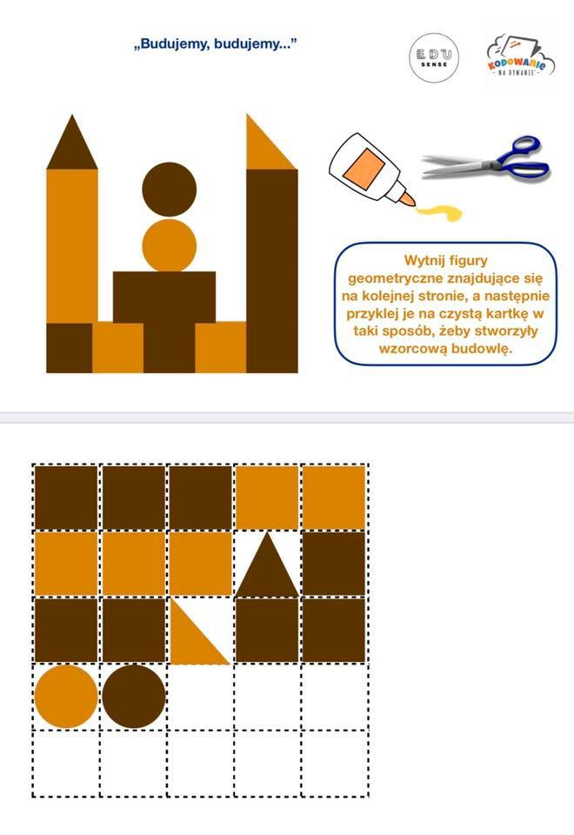Źródło: https://www.facebook.com/photo.php?fbid=1599131350242582&set=pcb.820999901731142&type=3&theater&ifg=1

